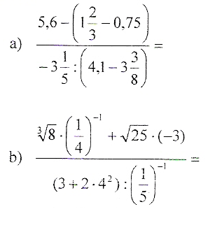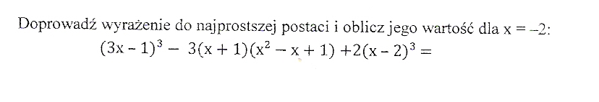

b) $\frac{\sqrt[3]{8}∙\left(\frac{1}{4}\right) ^{-1}+\sqrt{25}∙(-3)}{\left(3+2∙4^{2}\right):\left(\frac{1}{5}\right) ^{-1}}= \frac{2∙4+5∙(-3)}{\left(3+32\right):5}=\frac{8-15}{35:5}=\frac{-7}{7}=-1$

Doprowadź …..
$$\left(3x-1\right) ^{3}-3\left(x+1\right)\left(x^{2}-x+1\right)+2\left(x-2\right) ^{3}=27x^{3}-27x^{2}+9x-1-3\left(x^{3}+1\right)+2\left(x^{3}-6x^{2}+12x-8\right)=27x^{3}-27x^{2}+9x-1-3x^{3}-3+2x^{3}-12x^{2}+24x-16=26x^{3}-37x^{2}+33x-20$$
Dla x=-2
$$26∙(-2)^{3}-37∙(-2)^{2}+33∙\left(-2\right)-20=-26∙8-37∙4-2∙33-20=-208-148-66-20=-442$$

