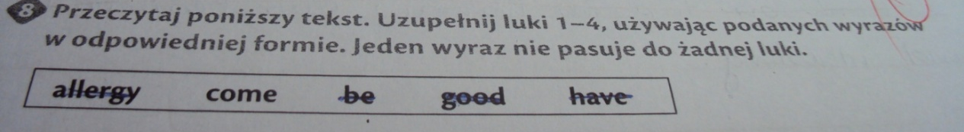
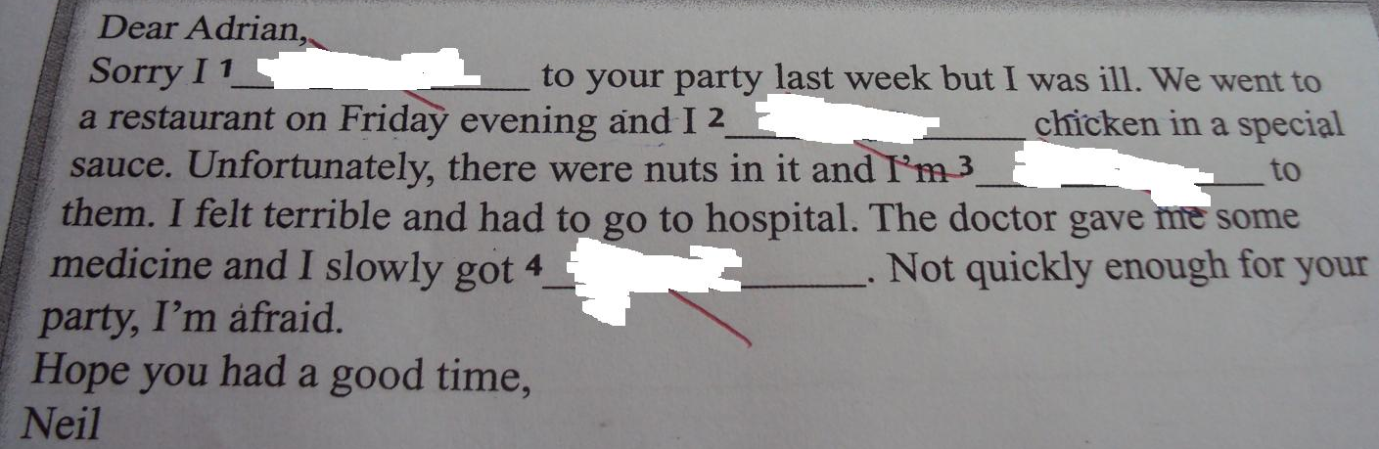
1. Sorry I didn’t come to your party last week but I was ill.
2.We went a restaurant on Friday evening and I have had chicken in a special sauce. 3.Unfortunately, there were nuts in it and I'm allergic to them.
4.The doctor gave me some medicine and I slowly got better.

