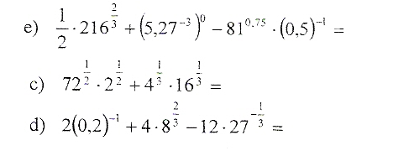

e) $\frac{1}{2}∙216^{\frac{2}{3}}+\left({5,27}^{-3}\right) ^{0}-{81}^{0,75}∙\left(0,5\right) ^{–1}=\frac{1}{2}∙\left(\sqrt[3]{216}\right) ^{2}+{5,27}^{1}-{81}^{\frac{3}{4}}=\frac{1}{2}∙6^{2}+5,27-\left(\sqrt[4]{81}\right) ^{3}=\frac{1}{2}∙36+5,27-3^{3}=6+5,27-27=5,27-21=-15,73$

c) ${72}^{\frac{1}{2}}∙2^{\frac{1}{2}}+4^{\frac{1}{3}}∙{16}^{\frac{1}{3}}=\left(72∙2\right) ^{\frac{1}{2}}+\left(4∙16\right) ^{\frac{1}{3}}=\sqrt{144}+\sqrt[3]{64}=12+4=16$

d) $2\left(0,2\right) ^{-1}+4∙8^{\frac{2}{3}}-12∙{27}^{-\frac{1}{3}}=2∙\left(\frac{1}{5}\right) ^{ ^{-1}}+4∙\left(\sqrt[3]{8}\right) ^{2}-12∙\left(\frac{1}{27}\right) ^{ ^{\frac{1}{3}}}=2∙5+4∙2^{2}-12∙\sqrt[3]{\frac{1}{27}}=10+4∙4-12∙\frac{1}{3}=10+16-4=22$

